1. 
2. Before understanding what Performance Testing is, we need to understand why we need performance Testing.
3. Let us understand why an example.
4. Suppose, Mark wants to buy mobile online worth 10,000 Dollar from Amazon and he searches for the desired phone.
5. After clicking on the buy button (after entering the Card Details), he has to wait for 2 minutes which is not good.
6. After 2min, he receives the msg 🡺 Thank you for shopping with us.
7. Now imagine what all would be going on within Mark Mind during these 2 minutes.
   1. What happened to my money?
   2. It is debited from my account or not?
   3. Should I cancel and go back?
   4. Etc.
8. After 2mins, maybe Mark gets the msg “Thank You for shopping with us” or “404”.
9. These kinds of transactions are **business critical transactions**.
10. Means, if a customer is not satisfied, we will lose credibility.   
    If we lose credibility, we will business.  
    If we lose business, we will lose Profits.
11. 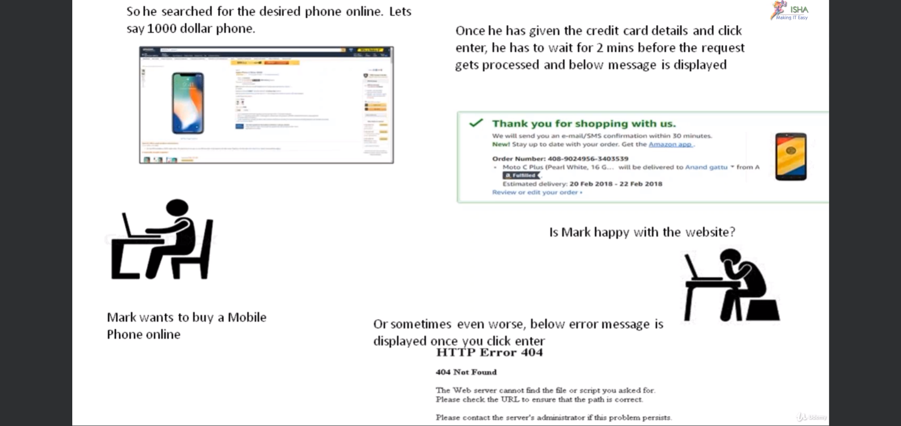
12. People do not want to wait that long but maximum 2 seconds.
13. Now Mark can move to some other shopping site like as customers are not that patient and they want things done quickly like within 2seconds otherwise App is too slow.  
    
14. 
15. **When Comparing performance testing with other testing like manual or automation, PT is expensive:**
    1. As tool is expensive.
    2. Performance Testers are expensive.
    3. For performance testing, Full scale infrastructure is required or half to build these servers, to build these kinds of data, again a lot of money is involved.

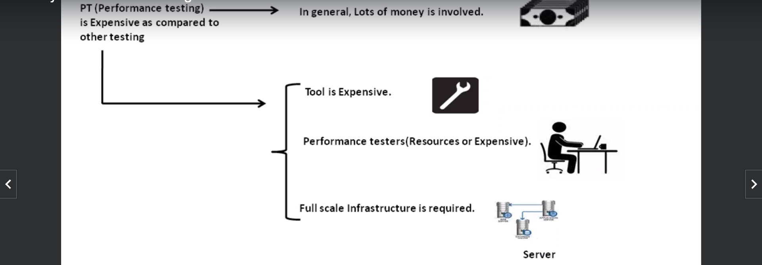

1. In spite of all this, the clients will sell out all this money to get performance in their app.